C3GIS TO C3GISR
Compress/Replica/Synchronization Process
Created by Rob Rahrs – 5/6/21

Step 1 – CREATE REPLICA FOR GEODATBASE
Developed replica tool using ArcGIS Toolbox. The screen capture below shows the actual “Create Replica” tool used for this process. The input is shown below.
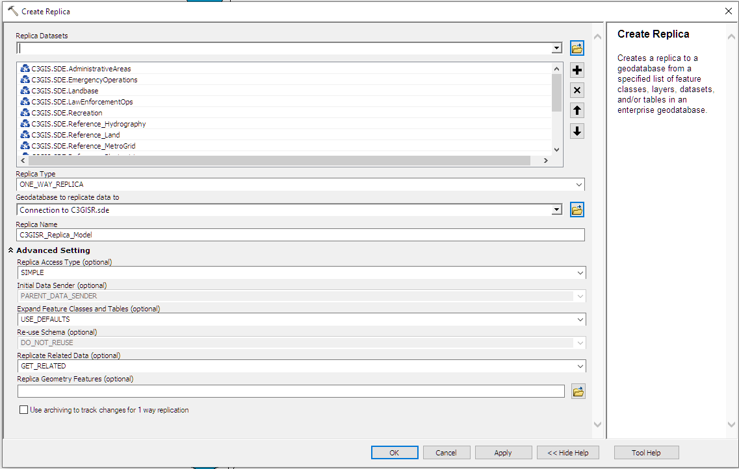
After running the tool, the newly created Replica process will reside in the parent geodatabase. You can access and administer the tool by Right clicking on the Geodatabase > Distributed Geodatabase > Manage Replicas > Replica Manager > Check the name.
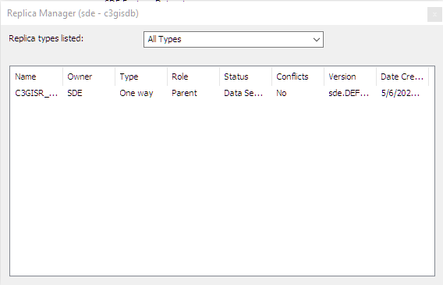
Helpful information in regards to schema changes and best practices using Replicas
https://desktop.arcgis.com/en/arcmap/latest/manage-data/geodatabases/working-with-schema-changes.htm

Step 2 – CREATE SYNCHRONIZATION FOR AUTOMATION
Create Synchronization of Replica process. The screen capture below illustrates the populated geodatabase. Notice it requests the name of the Replica process.
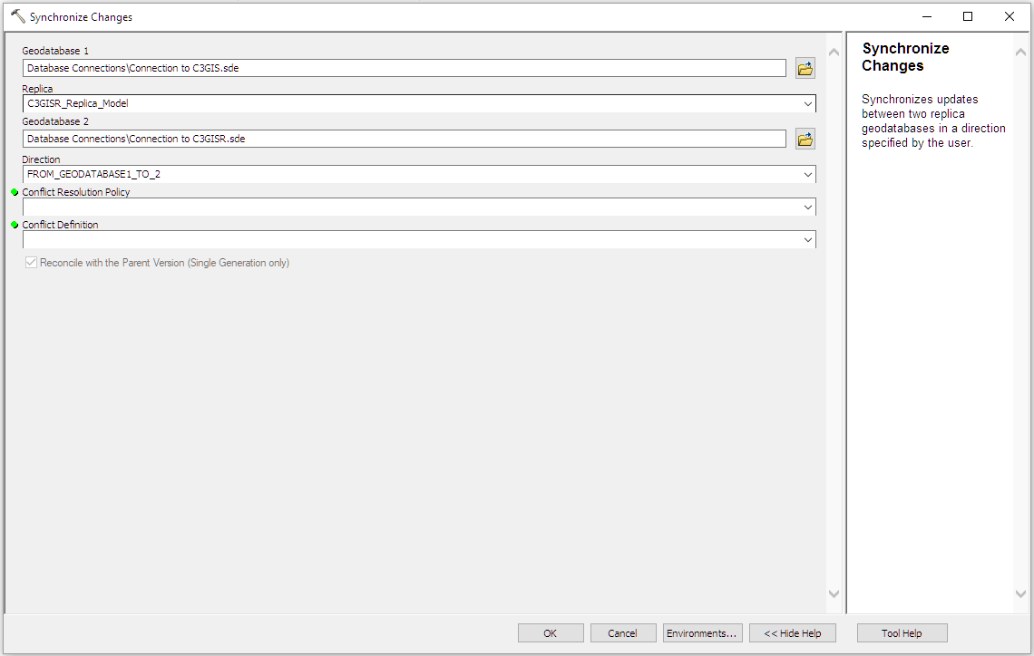
ESRI also shows the equivalent of this tool in python using the link below. https://resources.arcgis.com/en/help/main/10.2/index.html#//00170000001s000000
In order to automate this process, the python script was used. The image below is an example taken form the web link.
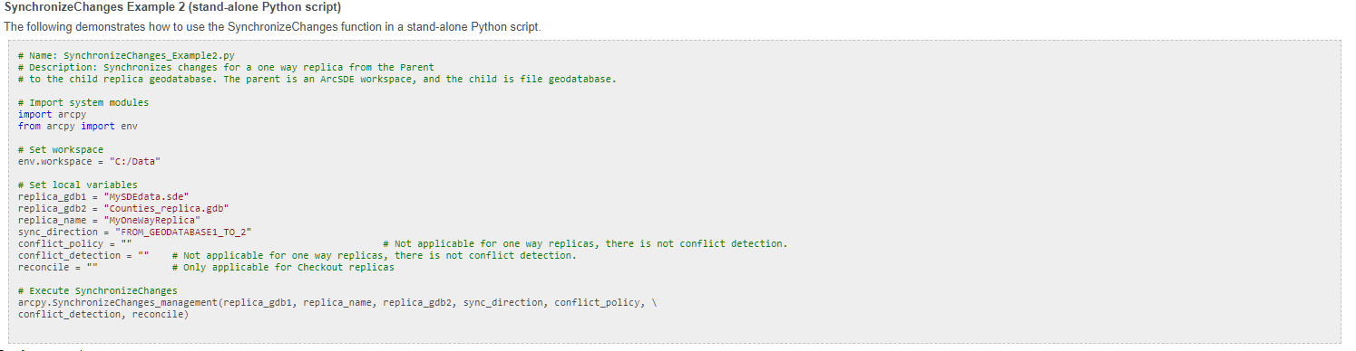
This script can be altered for our purposes and is seen below.

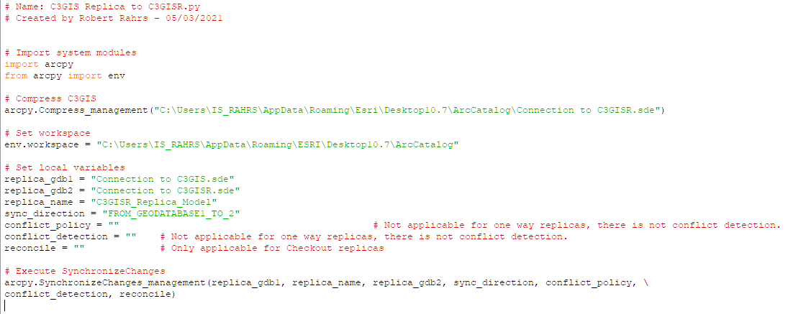
It’s a good process to “Compress” the database before making the replica. Thus, the following script was added from ESRI’s website.
https://desktop.arcgis.com/en/arcmap/10.3/tools/data-management-toolbox/compress.htm

Step 3 – Setting up the Task Scheduler
Use a server for this step that will constantly running. Do not run this on a laptop or desktop computer. Open Task Scheduler
- Open Start.
- Search for Task Scheduler, and click the top result to open the experience.
- Right-click the "Task Scheduler Library" branch, and select the New Folder option.
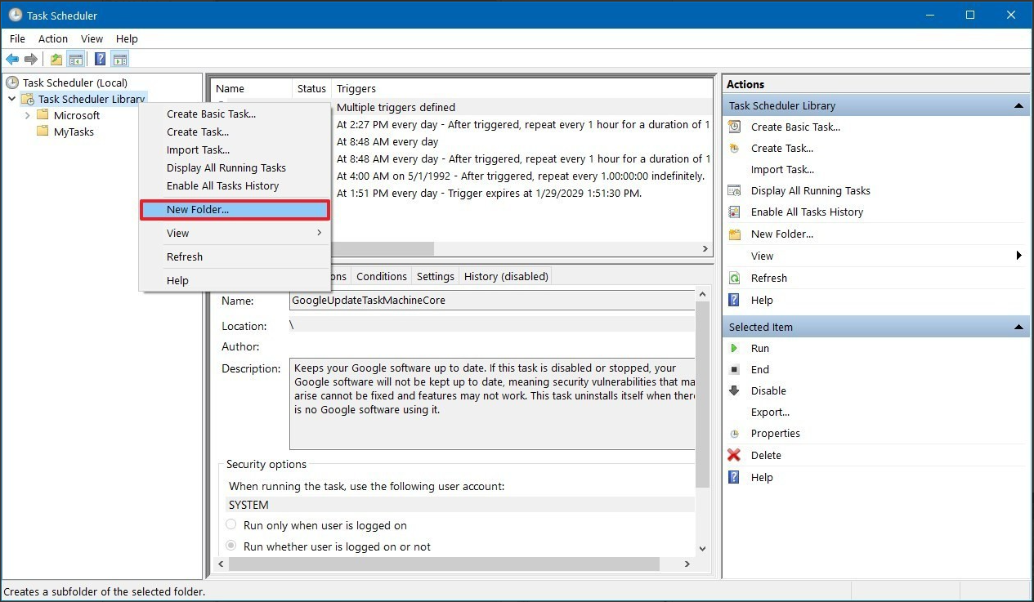

- Type a name for the folder. For example, MyTasks. (This step isn't a requirement, but it's a recommended step to keep your tasks separate from the system and apps tasks.)
- Click the OK button.
- Expand the "Task Scheduler Library" branch, and select the MyTasks folder.
- Click the Action menu.
- Select the Create Basic Task option.
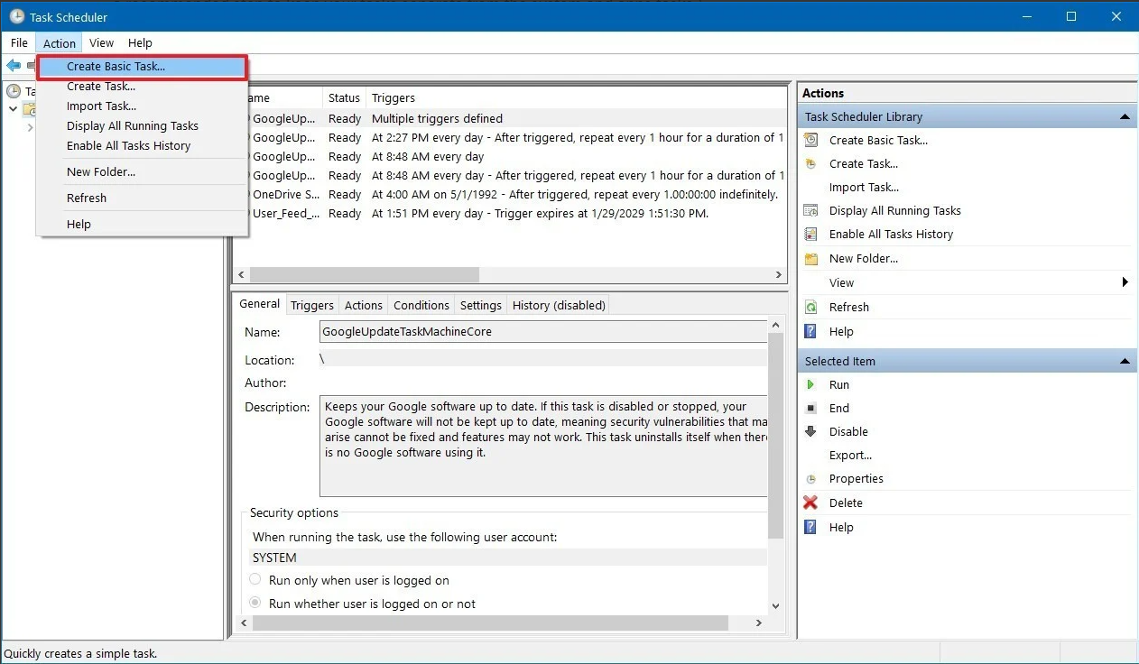

- In the "Name" field, type a short descriptive name for the task. For example, Notepad Launcher.
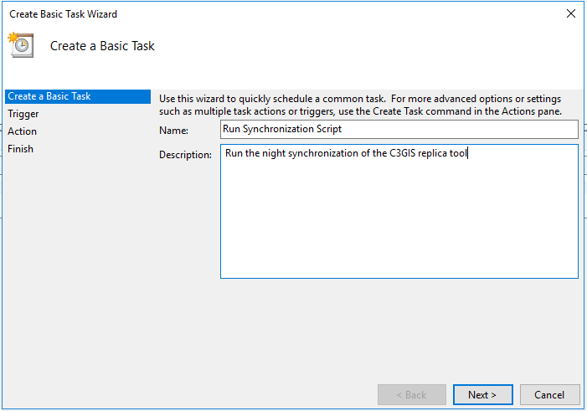

- (Optional) In the "Description" field, create a description for the task.
- Click the Next button.
- Select the Daily option.
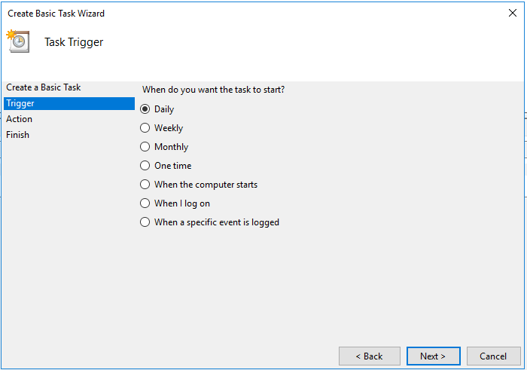

- Task Scheduler allows you to select from a number of triggers, including on a specific date, during startup, or when you or a particular user signs in. Depending on your requirements, you'll need to configure additional parameters. In this case, we'll be selecting the option to run a task every day starting at 1:15am.
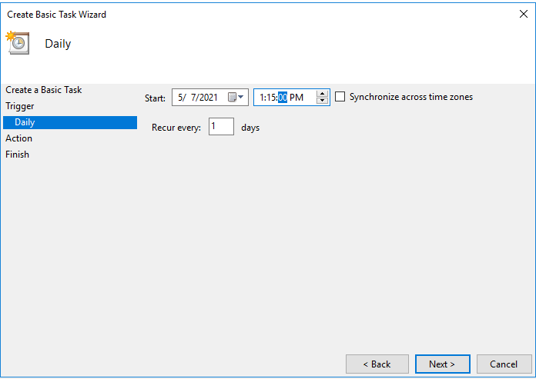

- Click the Next button.
- Select the Start a program option to launch an app, run a command, or execute a script file.
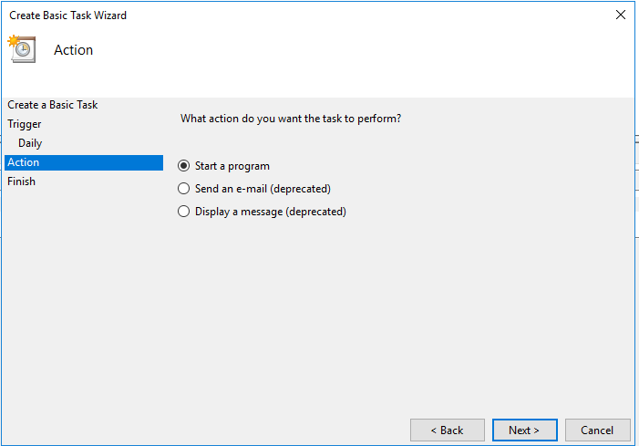
You can select the Send an e-mail or Display a message option, but these are deprecated features, which means that they may or may not work because Microsoft is no longer maintaining them.

- Send an e-mail: Triggers an email notification with a custom message on schedule, but it requires to specify an email server to work.
- Display a message: Allows to display a text message on the screen on schedule.

- In the "Program/script" field, specify the path for the application.
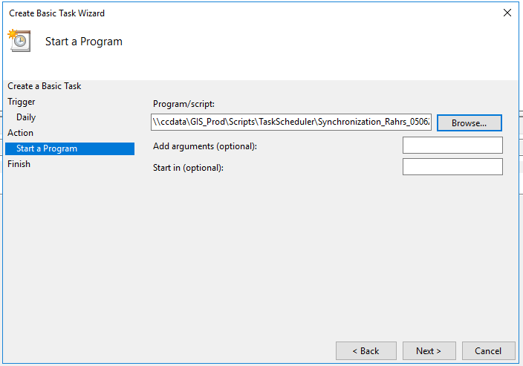
- Quick Tip: If you don't know the path of the app, click the Browse button to find it.

- (Optional) In the "Add arguments" field, you can specify arguments to run the task with special instructions.
- (Optional) In the "Start in" field, specify the folder in which the program will start. (Usually, you can leave this setting empty.)
- Click the Finish button.
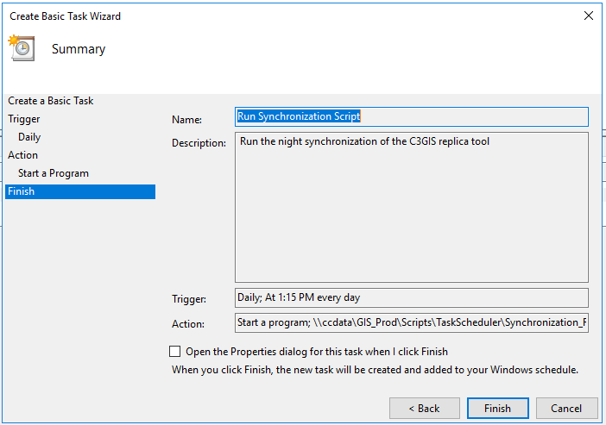

Once you've completed the steps, the task will be saved, and it'll run automatically on the schedule you specified.

Step 4 – Setting up email notification for errors
When a scheduled task fails to start, an event is written to the TaskScheduler event log:
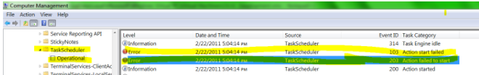

Windows lets you trigger scheduled tasks to start when a variety of events happen, e.g.:

- time of day
- system startup
- user login
- event recorded in event log
Armed with this knowledge, you can create a scheduled task that that runs when your scheduled task fails:
One of most common and lethal tool windows administrator is aware of when you want to send an automated email from task scheduler. However if you ever tried to set a windows task which will required to send an email in Windows server 2012, you will soon realize that it has been deprecated.
When you try to create a task through the task scheduler wizard, it does shows you option “Send an e-mail” but note what’s there is the bracket!
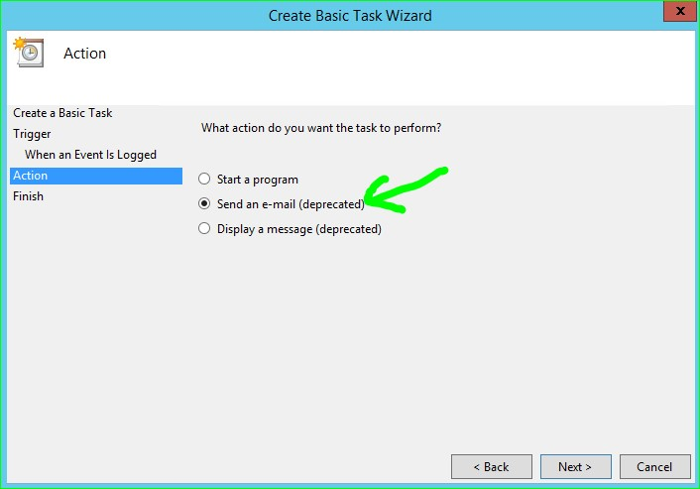
If you try to even go further in the wizard, it refuses to accept and dialogues out as ‘deprecated feature’.
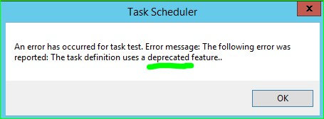
Well you certainly have the most trusted PowerShell to salvage.
Resolution:
We will work here with both the windows task manager feature and PowerShell script, where task will be created in Task manager and email will be sent using “ Run a Program/Script “ option in Action stage of setup.

Here we will see how to send email using Windows PowerShell and configure a Task in Windows Task Manager and setup email notification.
We will work here with both the windows task manager feature and PowerShell script, where task will be created in Task manager and email will be sent using “ Run a Program/Script “ option in Action stage of setup.
Here we will see how to send email using Windows PowerShell and configure a Task in Windows Task Manager and setup email notification.
Open notepad > Copy below Script > Change the highlighted with your details > save the file as PS1. e.g. “EmailScript.PS1”
$SmtpClient = new-object system.net.mail.smtpClient

$MailMessage = New-Object system.net.mail.mailmessage

$SmtpClient.Host = "SMTP.YOURcompany.com"

$mailmessage.from = ("DoNotReply_ToThisEmail@ YOURcompany.com ")

$mailmessage.To.add(" Person@ YOURcompany.com , Person2@ YOURcompany.com, …… ")

$mailmessage.Subject = “Alert Subject”

$mailmessage.Body = “Alert Body with Instruction to recipients”

$smtpclient.Send($mailmessage)

Create a basic task
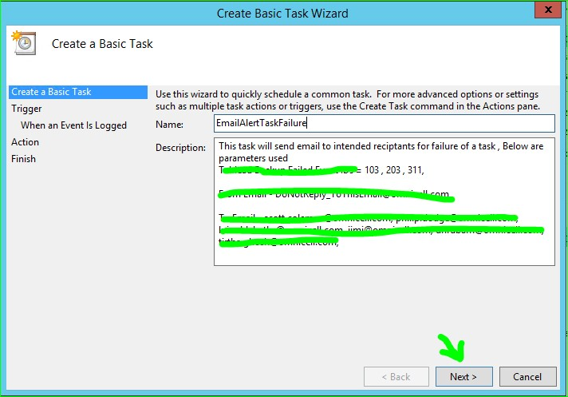
Select When A specific event Logged
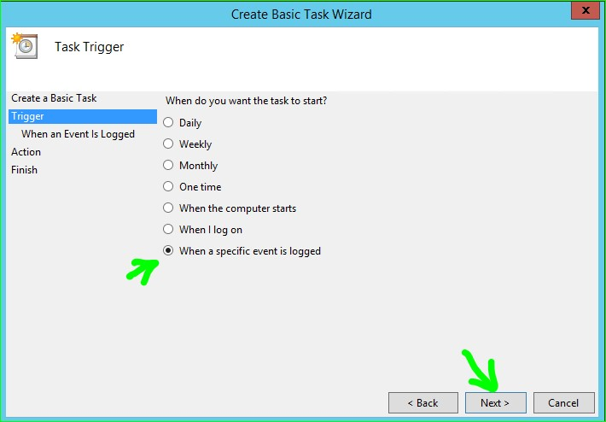

Select and furnish any trigger for which you want e-mail alert
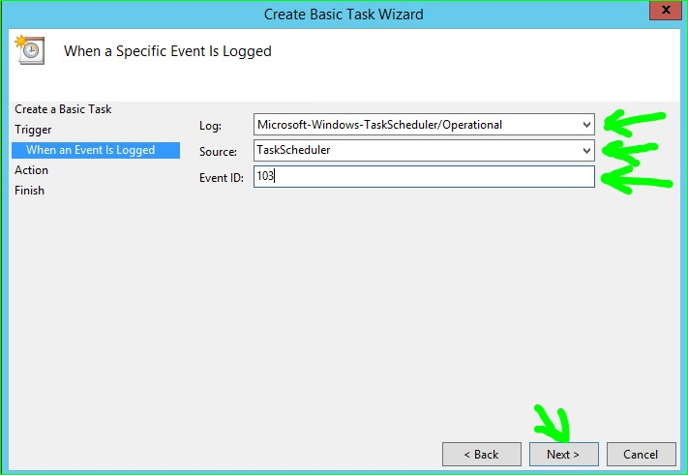
On next screen select “Start a program”
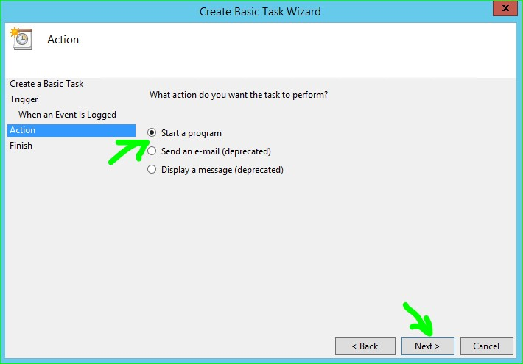

In program/script à type powershell.exe à In argument give the path of EmailScript.PS1 with file name
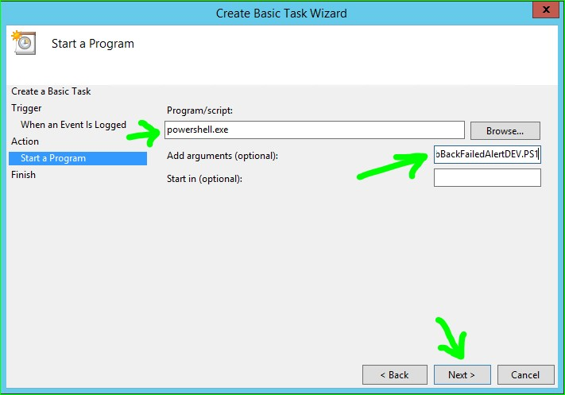
Check Open Property Dialog à Now Click Finish
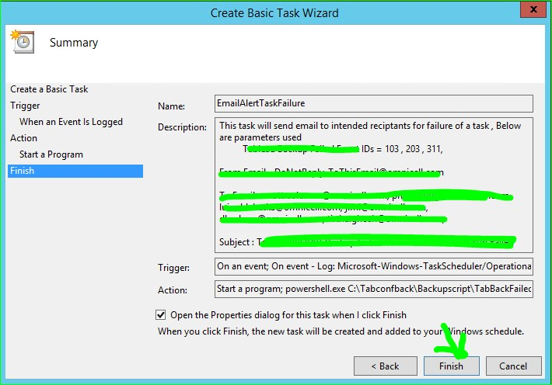

Check over the below options matches
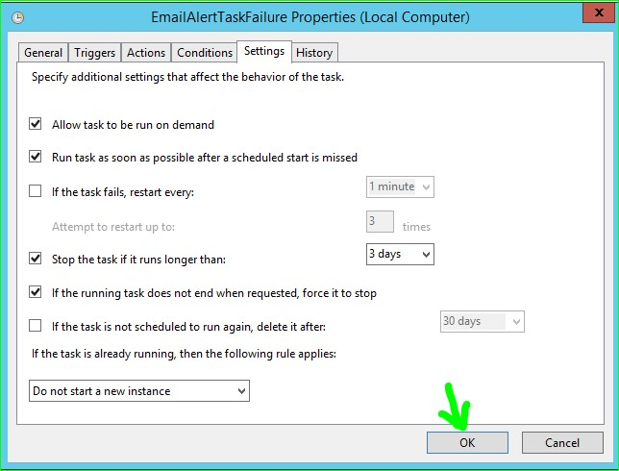
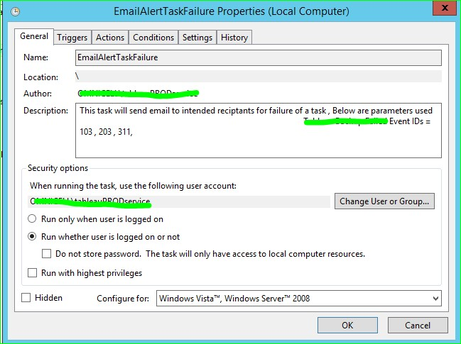

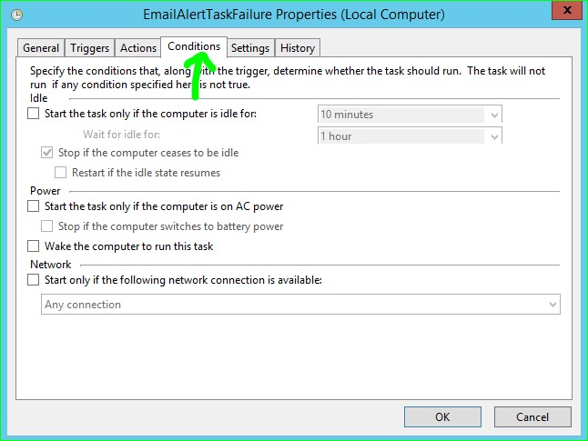

Similarly you can put multiple triggers of Event IDs
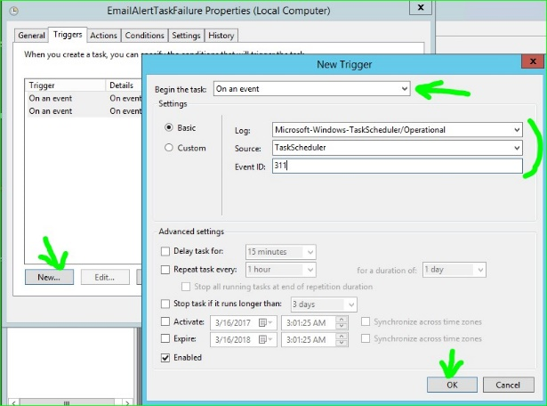

Perform this trigger for error events 103, 203, and 311.

